CLASS ASSESSMENT-1(19/06/24)

1.FIBONACCI SERIES USING RECURSION

Code:

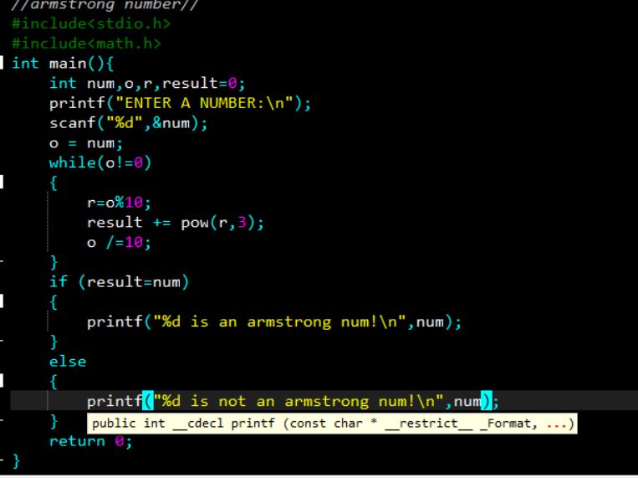

Output:

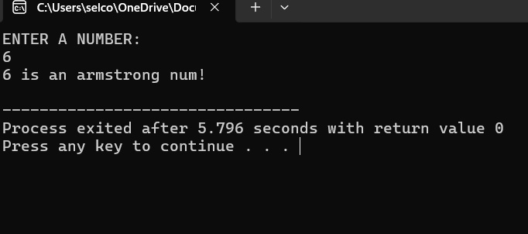

2.LARGEST ELEMENT IN AN ARRAY:

CODE:

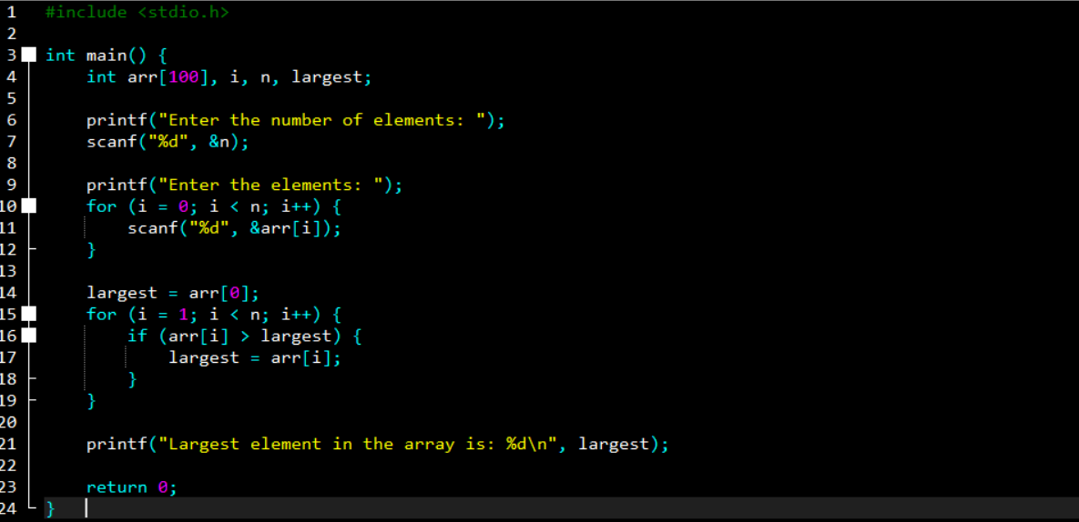

OUTPUT

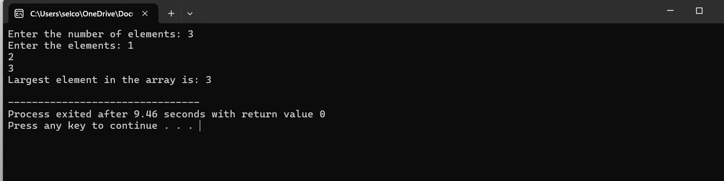

3. FIBANACCI SERIES USING RECURSION IN C

CODE:

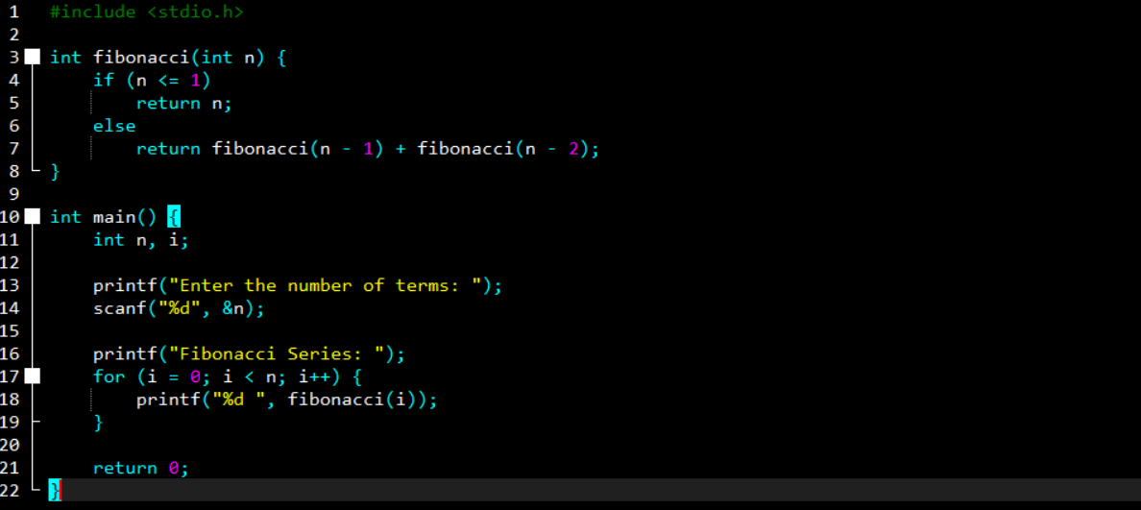

OUTPUT:

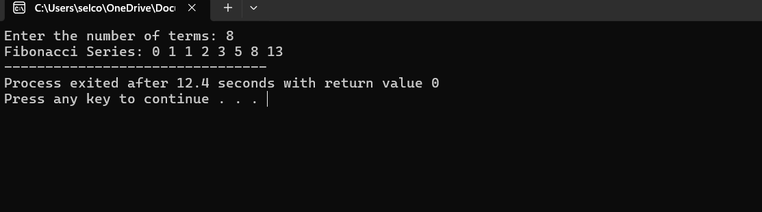

4.GCD OF TWO NUMBERS USING RECURSIVE FACTORISATION

CODE:

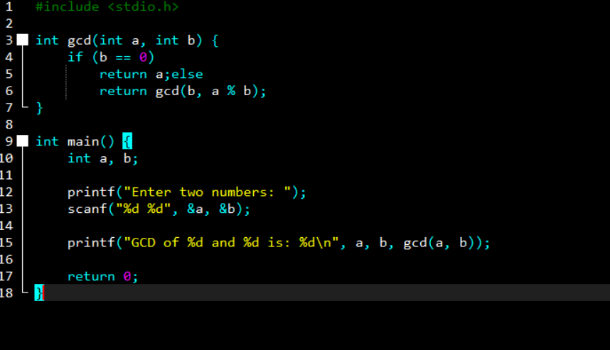

OUTPUT:

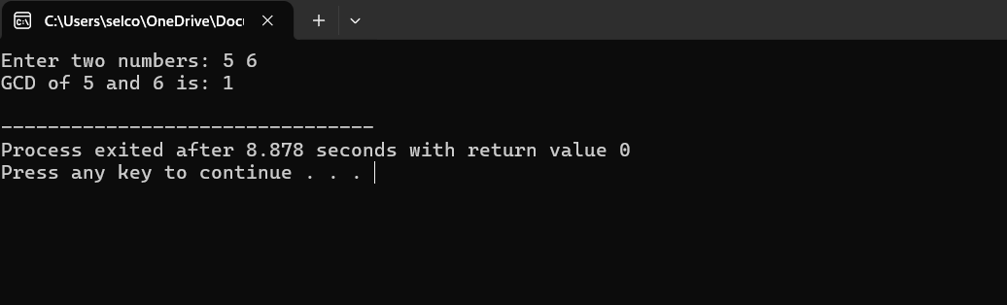

5.FACTORIAL PROGRAM USING RECURSION

CODE:

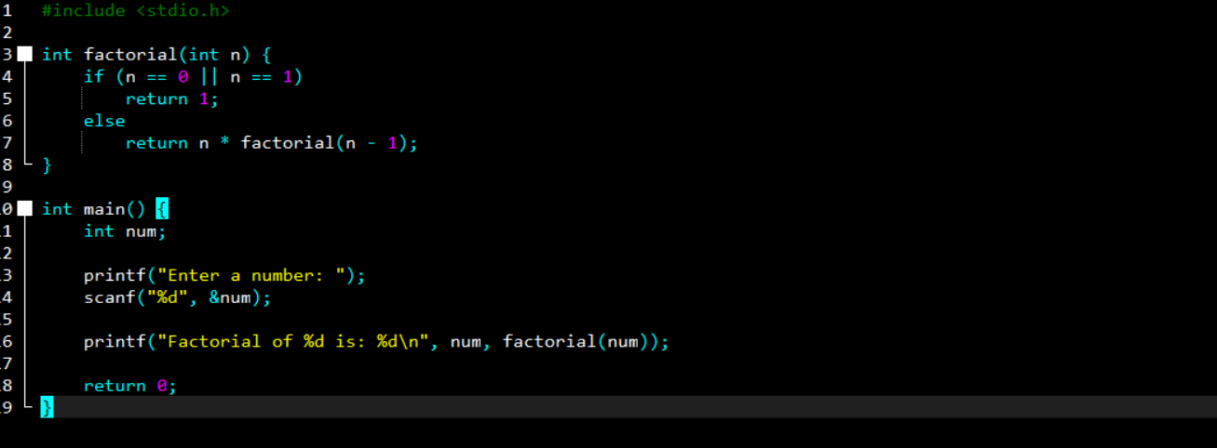

OUTPUT:

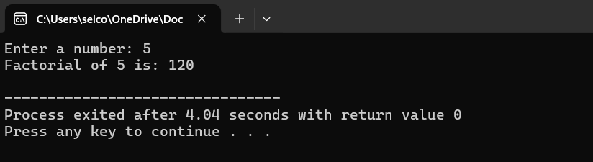

6.COPY ONE STRING TO ANOTHER USING RECURSION

CODE:

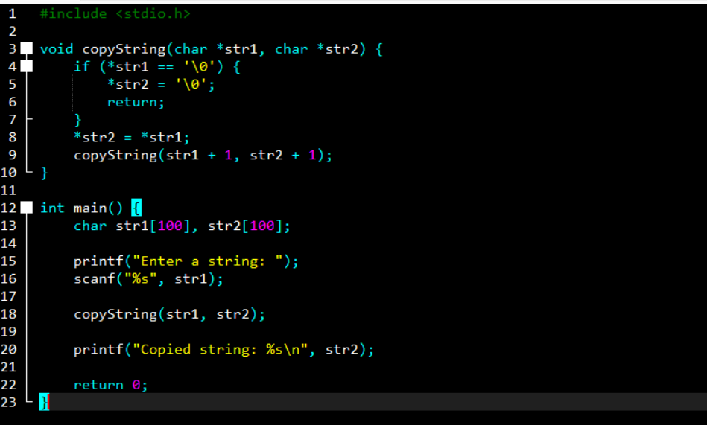

OUTPUT:

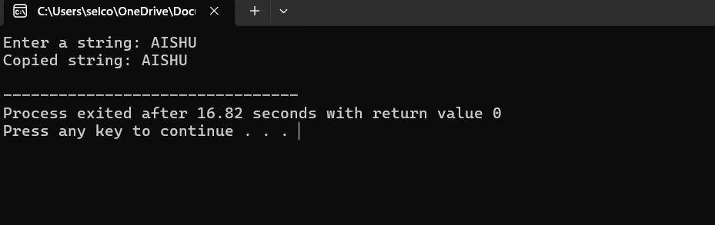

7.GENERATE ALL PRIME NUMBERS UPTO 50 USING RECURSION IN C

CODE:

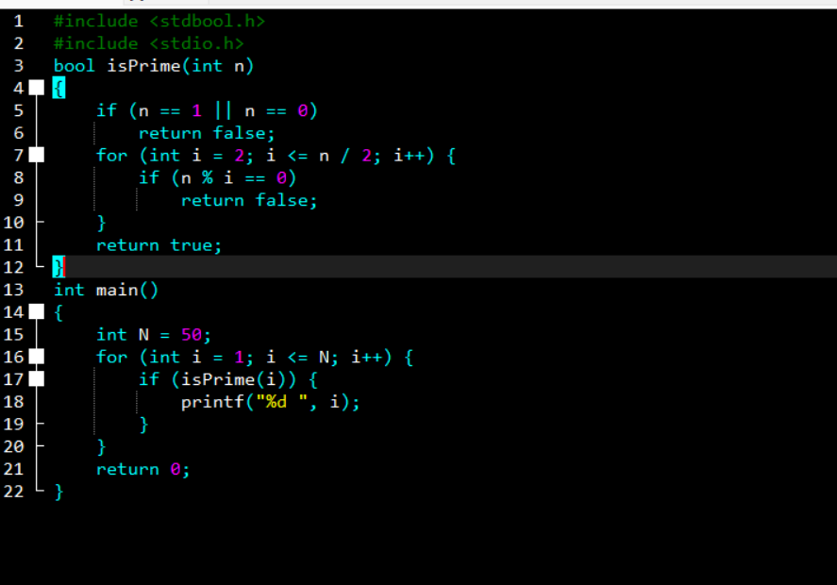

OUTPUT:

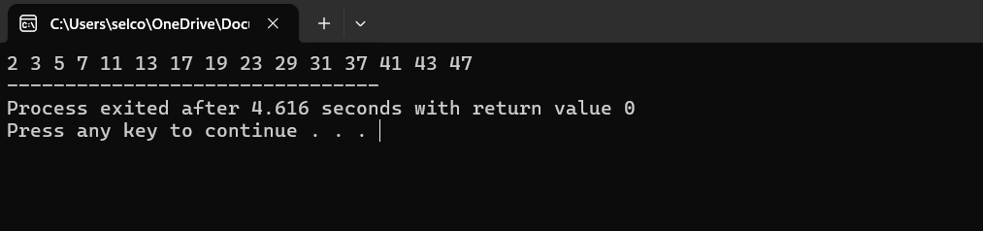

8.REVERSE A STRING USING RECURSION IN C PROGRAM

CODE:

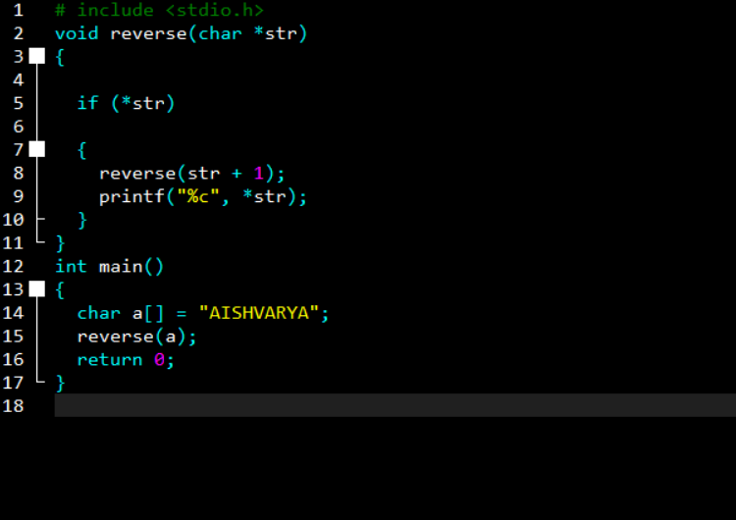

OUTPUT:

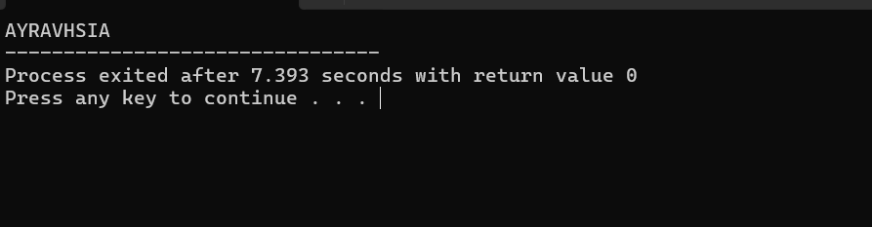

9.STRING PALINDROME USING RECURSION IN C

CODE:

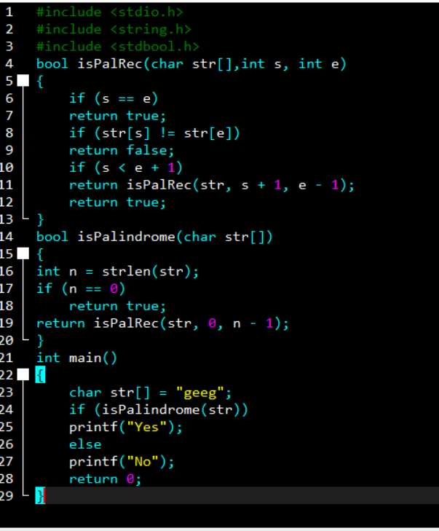

OUTPUT:

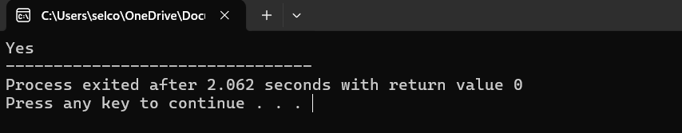

10.CHECK IF A NUMBER IS PRIME OR NOT

CODE:

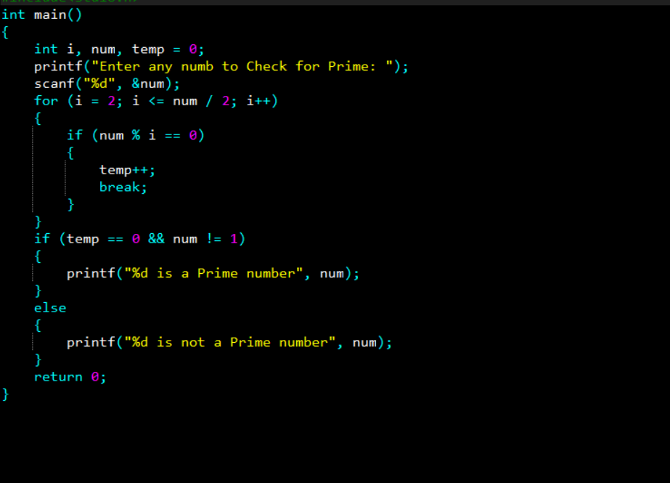

OUTPUT:

